# Patient Information

**Neuberg Diagnostics Private Limited, Thombra Arcade, Ernakulam**

Covid-19 Test Report

Patient ID

2341200248552 Name: AKSHARA KASHYAP

Age: 26 Years Gender: Female

Contact Number:

8878209003 Country

of Test:

India

Adhaar Number:

Not available Passport

Number:

Not available

**Specimen Information**

ICMR ID: 607382930 SRF ID: 2341200248552

Result of SARS- CoV2:

Negative Test Type: RTPCR

Specimen Type: Nasopharyngeal swab Report ID: 2341200248552

Date Time of Sample Collection:

25-12-2021 13:17:14 Date Time of

Sample Received at Lab:

26-12-2021 08:30:24

Date Time of Sample Testing:

26-12-2021 09:00:24 Date Time of Result Reported:

26-12-2021 18:53:47

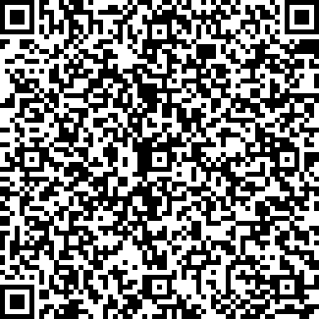

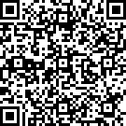

Scan for e-Verify

**Note: The results relate only to the specimens tested and should be correlated with clinical ﬁndings.**

**Interpretation guidance:-**

1. Testing of referred clinical specimens was considered on the basis of request / referral received from / through State Surveillance Officer (SSO) of concerned State Integrated Disease Surveillance Programme (IDSP)/ any other health care facility affirming requirements of the case definition/s.
2. A single negative test result, particularly if this is from an upper respiratory tract specimen, does not exclude infection*
3. A positive test result is only tentative, and will be reconfirmed by retesting
4. Repeat sampling and testing of lower respiratory specimen is strongly recommended in severe or progressive disease. The repeat specimens may be considered after a gap of 2 – 4 days after the collection of the first specimen for additional testing if required. *
5. A positive alternate pathogen does not necessarily rule out either, as little is yet known about the role of coinfections.
6. Please note that these results are not to be used for any thesis or presentations or for Publication in any Journal without the prior permission of the Director General, ICMR